Generative AI using LangChain | GENAI for Beginners | CampusX
https://www.youtube.com/watch?v=_3ezSpJw2E8&list=PLKnIA16_RmvaTbihpo4MtzVm4XOQa0ER0&index=2
00:00 – Intro
03:07 - What is Langchain?
06:26 - Why LangChain First?
08:19 - Curriculum Structure
11:06 - Focus for this Playlist
13:42 - Timeline for this Playlist
1. Purpose of This Video and Playlist
This playlist belongs entirely to the User Side of Generative AI, where we build applications using existing foundation models.

2. Position of LangChain in the GenAI Curriculum
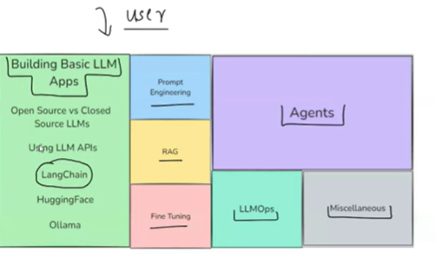
Generative AI is divided into two parts:
- Builder Side → Building foundation models
- User Side → Using foundation models to build applications
LangChain lies in:
User Side – “How to build LLM-based applications”
Before learning:
- Prompt Engineering
- RAG
- Fine-tuning
- Agents
- LLMOps
We must first learn:
How to practically build LLM-based applications
LangChain is used as the entry point for this.

3. What is LangChain?
3.1 Simple Definition
LangChain is:
An open-source framework used to build LLM-based applications
Examples of LLM-based applications:
- Chatbots
- Question-answering systems
- RAG-based systems
- Autonomous AI agents
LangChain provides:
- Modular components
- End-to-end tools
- Abstractions to reduce boilerplate code

3.2 Why LangChain Became Popular
LangChain became popular due to the following core features.
1. Supports Almost All Major LLMs
- Open-source LLMs
- Closed-source LLMs
Examples:
- OpenAI GPT models
- Anthropic Claude
- Hugging Face models
- Ollama-based local models
👉 This makes LangChain vendor-agnostic.

2. Simplifies LLM Application Development
LangChain introduces abstractions such as:
- Chains
- Prompts
- Memory
- Agents
These abstractions make it easy to build:
- Simple apps
- Highly complex GenAI systems
Without LangChain:
- Large amount of glue code
- Harder orchestration

3. Rich Integrations Ecosystem
LLM applications rarely work alone. They need:
- Databases
- APIs
- File systems
- Vector databases
- Deployment tools
LangChain provides:
- Ready-made wrappers
- Easy integrations
- Minimal boilerplate

4. Free and Open Source
LangChain is:
- Free
- Open source
- Actively developed
Multiple versions have already been released in a short time, showing:
- Strong community support
- Rapid evolution

5. Supports All Major GenAI Use Cases
LangChain can be used to build:
- Chatbots
- RAG-based applications
- AI agents
- Tool-using AI systems
It acts like an all-rounder framework for GenAI application development.

Industry Perspective (Why This Matters)
In real-world companies:
- Teams don’t want to lock themselves to one LLM
- APIs and models change frequently
- Abstraction layers are critical
LangChain acts as:
A middleware layer between LLMs and applications
This is why it is widely adopted in startups and enterprises.

4. Why LangChain Is Taught First
4.1 Holistic Exposure to User-Side GenAI
By learning LangChain first, learners automatically get exposure to:
- Open-source LLMs
- Closed-source LLMs
- Prompt engineering
- RAG
- AI agents
- Even a glimpse of LLMOps
LangChain touches every important user-side concept.

4.2 One Framework, Multiple Skills
Using LangChain, you can:
- Call LLM APIs
- Integrate Hugging Face models
- Run local models with Ollama
- Build RAG systems
- Create AI agents
This gives:
A complete bird’s-eye view of the GenAI user-side landscape

4.3 Learning Strategy Behind This Choice
The idea is:
- First, get a holistic overview
- Then, revisit each topic later with deep-dive playlists
Planned later:
- Dedicated Prompt Engineering playlist
- Dedicated RAG & Advanced RAG playlist
This avoids:
- Fragmented learning
- Context switching too early

5. Curriculum Structure of the LangChain Playlist
The LangChain playlist is divided into three major parts.
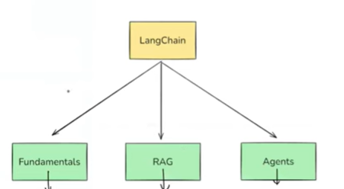

5.1 Part 1: LangChain Fundamentals
This is the most important section.
Topics covered:
- What is LangChain
- Why LangChain is needed
- LangChain architecture
- Core components overview
Practical work starts after:
- Conceptual foundation is clear
Key modules include:
- Models
- Prompts
- Output parsing
- Runnables / LCEL
- Chains
- Memory integration
These form the foundation layer.

5.2 Part 2: RAG Applications
This section focuses on Retrieval-Augmented Generation.
Topics include:
- Document loaders
- Text splitters
- Embeddings
- Vector databases
- Retrievers
Final outcome:
Building a complete RAG application from scratch

5.3 Part 3: AI Agents
This is the most advanced part.
Topics include:
- Tools and toolkits
- Tool calling
- Agent architecture
Final outcome:
Building a working AI agent

Industry Perspective (Why This Structure Is Practical)
In real GenAI teams:
- Engineers first learn fundamentals
- Then work on RAG (most common enterprise use case)
- Then move to agents (advanced automation)
This curriculum mirrors industry learning progression.

